In this and the following labs we will build an applied solution for accounting in a sales company.
Types of objects will be indicated in brackets, which will be written in italics. If additional information in the form of numbers or words is indicated after the type in brackets (Number(15)/Number(15, 3, non-negative), String(150)/String(150, Fixed-length), Date(Date and time)), this indicates the addition of a primitive type (string, number, date).
- For a string it is the maximum length and a sign whether a string should have a fixed length. By default string can have a variable length.
- For a number it is the maximum length, the fractional part (precision) and a sign of whether a number can be negative.
- For a date - type of date (date/time/date and time).
If an attribute is required to fill, its name will be indicated in bold or it will be described additionally. Example: Add an attribute Price (Number(15)).
Since the task does not explicitly state object of which metadata class to create, you must determine the appropriate description length when creating catalogs, because the default length is 25 characters and in many cases this is not enough to enter information:
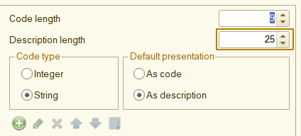

- Create a new file infobase. Call it with your full name.
- Select a suitable metadata class for countries list and create a configuration object Countries.
- Select a suitable metadata class for list of products and services and create a configuration object Products. This object should contain information about Weight (Number(15, 3, Non-negative)), FullDescription (String(500)) and CountryOfOrigin (type of object from p.2). This object must be named differently in different parts of the solution:
- The command to create a new product must be called “Product”.
- In the object form the title should be “Product/Service”.
- The command to open the list of products should be called “Products”.
- In the list form the title should be “Products list”.
- Select a suitable metadata class for products type and create a configuration object ProductsTypes to store values: InventoryItem, Service, ContractWork. Create an attribute ProductsType with this new type at the Products configuration object. Specify a default value InventoryItem for it and make it required to fill.
- Create a subsystem “Master data” and include all previously added objects in it.
- Select a suitable metadata class for list of customers and suppliers and create a configuration object Counterparties. This object should contain information about TIN (Taxpayer Identification Numbers) (String(12)), RegistrationCountry (type of object from p.2). This object should be name as “Counterparty” in the singular form.
- Select a suitable metadata class for sales operations and create a configuration object SalesInvoice. This object should contain information about Customer (type of object from p.6) and products/services in a nested object Products that allows to store several goods and services - Product (type of object from p.3), as well as their Quantity (Number(15, 3, Non-negative)) and Price (Number (15, 0, Non-negative)). This object should be name as “Sales invoices” in the plural form.
- Create a subsystem “Sales” and include objects from points 6 and 7 to it.
- Update database configuration, run the infobase at Enterprise mode and add some data to your new objects (at least 5 for each object).

